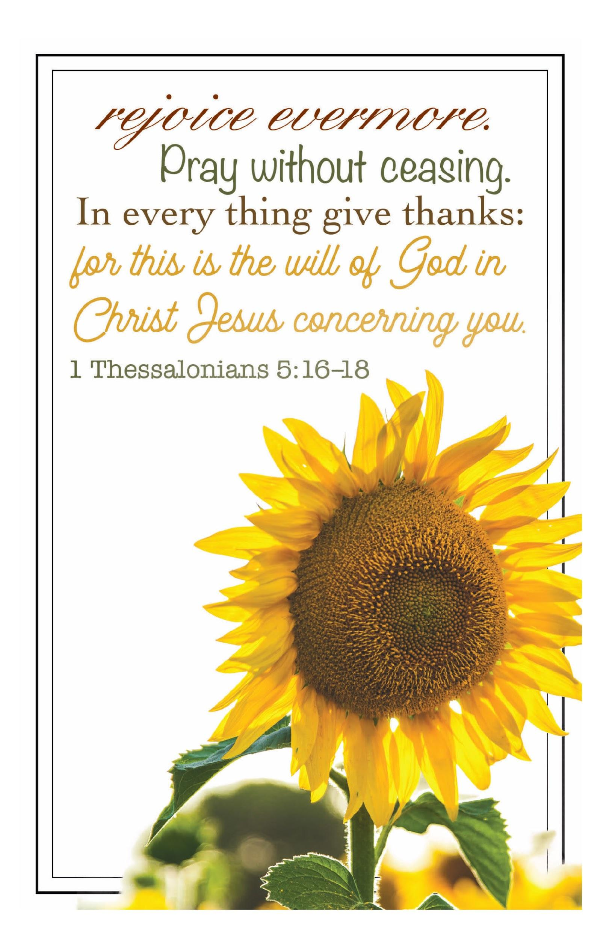
TYPE HERE
This bulletin, available for download, can be emailed to church members, posted to church websites and social media, and easily shared with church members digitally.

TYPE HERE

TYPE HERE
Be creative!
Use boxes within these pages to add clip art,
logos, maps, highlight text, etc.

To add a box, click on Insert and Text Box.
Your cursor will look like a +.
Simply click and drag the size box you
desire in the appropriate space.

Even if you are not printing on a color printer,
do not hesitate to add clip art to your bulletin.
Clip art printed in black and white
looks great too!

